Question 1(a)
- 0x0112
- 0x1101
- 0x1101
- 0x0200
Question 1(b)
- Not possible
- Not possible
- 0110
- 00F0
- 00FF
- 0101

Question 2
[ORG 0x0100]
mov SI,0
mov DI,0
mov BH,5AH
again:

MOV AL,[InString+DI]
MOV AH,[InString+DI]
inc DI

cmp AH,BH
jle tolower

SUB AL,32
mov [OutString+SI],AL
inc SI

MOV AL,[InString+DI]
JNZ again
jmp here

tolower:
ADD AL,32
mov [OutString+SI],AL
inc SI
jmp again

here:
MOV AX, 0x4C00 ; TERMINATE PROGRAM
INT 0x21

InString: db "Your Name",0
OutString: db ""

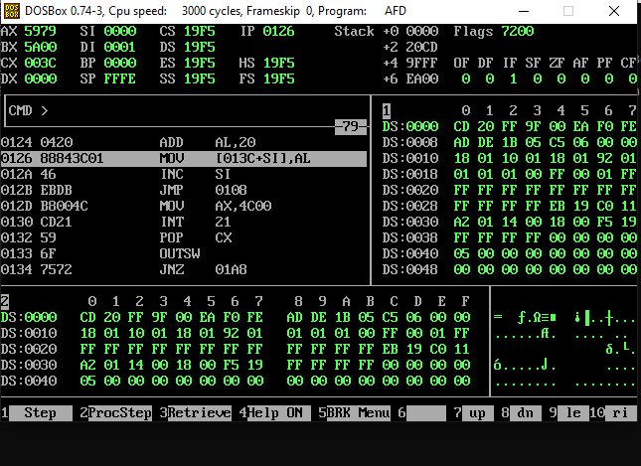
Question 3
[ORG 0x0100]
mov cx,10
mov SI,0
mov ax,0
mov bl,0
here:
mov bl,[Numbers+SI]
add al,bl
inc SI
loop here
MOV AX, 0x4C00 ; TERMINATE PROGRAM
INT 0x21

Numbers: db 59,75,86,92,58,18,8,29,92,32
